**Data Motion in the TRP Environment**

Version 1.3

Jan 2015

Prepared by:

Nirmal Raj

[nirmal.raj@thomsonreuters.com](mailto:arndt@netapp.com)

**Abstract**

This paper documents the steps for performing non-disruptive data migrations using NetApp Data Motion for vFilers in the Thomson Reuters Professional (TRP) environment.

**TABLE OF CONTENTS**

1 INTRODUCTION 3

1.1 Conventions 3

1.2 Requirements and supported configurations 4

2.2 Choosing the migration type (Online or offline) 7

2.3 Choosing the destination storage system 9

2.4 Modifying the aggregate mappings 9

2.5 Configuring the network bindings 10

2.6 Specifying a transfer throttle 12

2.7 Choosing the cutover type 12

2.8 Final steps of migration initialization 13

2.9 DFM alert when performing baseline data transfer 15

2.10 Updating the snapmirror.conf settings on the destination storage system 15

3 Performing the cutover 16

3.1 Checking the status of the data transfers and initializing the final cutover 16

3.2 The script path option 17

3.4 Network routes 17

3.5 Cutover summary screen 18

3.6 Finalizing the cutover 18

3.7 Troubleshooting a failed cutover attempt 20

4 Cleanup work 21

4.1 Cleaning up the source vFiler flexvols 21

4.2 Cleaning up SnapMirror related snapshots 22

4.3 Correcting the dataset physical properties 22

5 Resources 23

# 1 INTRODUCTION

This paper documents the steps for performing non-disruptive data migrations using NetApp Data Motion for vFilers in the Thomson Reuters Professional (TRP) environment. This document assumes that the reader is familiar with basic NetApp storage management concepts such as vFilers, aggregates, flexible volumes (volumes, or flexvols), and SnapMirror.

### 1.1 Conventions

The following conventions are used throughout this document:

*NMC -> list-> list*

The convention above indicates a list of links to click on in order to accomplish a task using the Provisioning Manager interface in the Network Management Console.

*netapp>*

The convention above indicates a command to run on a NetApp storage system.

*dfm>*

The convention above indicates a command to run on a DFM server.

### 1.2 Requirements and supported configurations

Online Data Motion for vFilers requirements:

Data OnTap 7.3.3P3 or higher with the multistore, snapmirror, and snapmirror_sync licenses (KZZTWOJ).

* Provisioning Manager 4.0D15 or higher.
* Data configured in the Multistore (vFiler) model.

Online Data Motion for vFilers supported configurations:

* Between clustered storage systems only:
  + No movement between controllers in the same cluster.
  + No movement between aggregates on the same controller.
  + No movement between single controller systems.
* From equal or less powerful to more powerful clusters - examples:
  + Movement from FAS6080 to FAS6080 cluster is OK.
  + Movement from FAS3140 to FAS3140 cluster is OK.
  + Movement from FAS3140 to FAS6080 cluster is OK.
  + Movement from FAS6080 to FAS3140 cluster is not currently allowed.
* Maximum number of flexvols per vFiler:
  + FAS3xxx – maximum of 8 flexvols per vFiler.
  + FAS6xxx – maximum of 20 flexvols per vFiler.
* For data in vFilers accessed via NFS or iSCSI only:
  + Any data accessed via CIFS will experience a disruption
* During low utilization periods of activity on the storage systems.
  + Provisioning Manager will warn you if system utilization is too high.
  + CPU utilization must be below 90% on each storage system regardless of the workload on the vFiler being migrated.
  + How far below 90% the CPU utilization must be depends on the workload of the source and destination storage systems, as well as the workload on the vFiler being migrated.
* During normal system operation:
  + Neither the source nor the destination can be in takeover mode
* Other requirements and limitations:
  + vFilers to be migrated must own entire flexvols, not qtrees.
  + Identically named IpSpaces must exist on the source and destination storage systems.
  + All flexvols must be 10GB in size or larger. Provisioning Manager will automatically resize vFiler root flexvol before and after the migration process to meet this requirement.
  + Deduplicated flexvols will have their fingerprint DB recreated after a migration with the *netapp> sis start –s* command.
  + If iSCSI is enabled on the vFiler, the *iscsi.ip_based_tpgroup* option must be *on*.
  + There cannot be any active snapvault transfers in progress during the final cutover.

TRP environment configuration requirements:

* A 1GbE or faster network interface on the TRP management network for the storage system.
* Working DNS resolution for both the simple hostname and FQDN of the source and destination storage systems. This can be tested using the “*ping*” command on the storage systems.
* For **ISCSI_nosnap** volume and **noniscsi_nosnap** volume ensure below step is followed before initiating Data motion
  + Confirm SOURCE Aggregate has sufficient capacity
  + For iSCSI _nosnap volumes, add space and set 50% snap reserve:  
    vol_size=((current_size/(reserve/100))  
    Current volume size divided by .5 = (x)g  
    Run command “vol size <volname> (x)g”  
    Run command “snap reserve <volname> 50”
  + For non iSCSI _nosnap volumes, add space and set 20% snap reserve:  
    vol_size=((current_size/(reserve/100))  
    Current volume size divided by .8 = (x)g  
    Run command “vol size <volname> (x)g”  
    Run command “snap reserve <volname> 20”
  + This is required in order for SnapMirror snapshots to be used during the migration process, in conjunction with snap auto delete being in place. The snap reserve can be set back to 0 and volume resized when the migration is finished
* For _snap volumes ensure there is enough space available. Increase as needed.
* If the CPU utilization is consistently too high to perform the final cutover of an online migration, Try temporarily disabling deduplication on the source and/or destination storage controllers.
* If the vol autosize feature is enabled on the vFiler root volume, and the maximum size

configured for the volume is under 10GB, use the following steps to ensure that this does not

conflict with the cutover phase of an online migration:

* + Disable vol autosize prior to the cutover.
  + Manually grow the vFiler root volume to 10GB in size prior to the cutover.
  + Manually shrink the vFiler root volume back to it’s original size after the cutover.
* Enable vol autosize again after the cutover.
* Clients might experience the following during online migration:
  + • iSCSI clients experience up to 120-second pause in input/output (I/O).
  + • NFS clients experience up to 120-second pause in I/O.
  + • Clients reestablish NFS locks as they would during a high-availability takeover.
  + • CIFS client sessions are terminated after cutover, and the clients must reconnect
* If it is offline migration application needs to be brought down before performing cutover**2 Initiating a migration with Data Motion for vFilers**

In the contents of this section, we show the steps for initiating a migration with Data Motion for vFilers.

**2.1 Starting a migration**

To start a migration, go to *NMC->ProvMgr->Hosts->vFiler Units,* select the vFiler that you wish to migrate, and click on *Start migration* per the following screenshot:

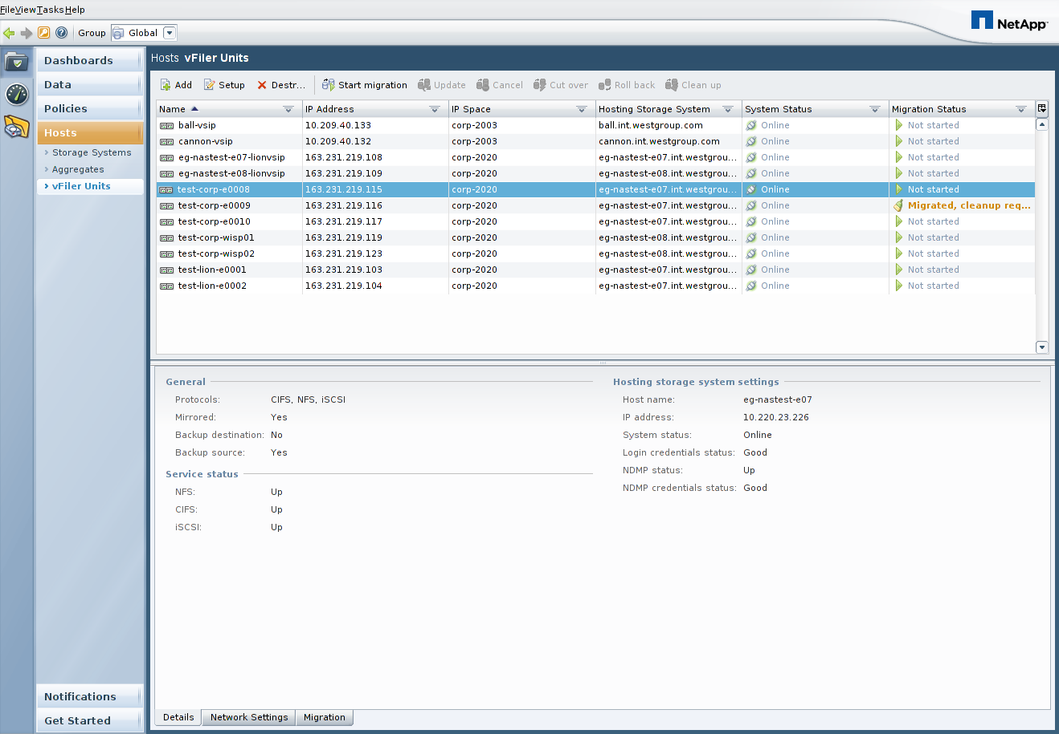

After you click on *Start migration*, a migration wizard will walk you through the required steps, as we will document in the remainder of section 2.

### 2.2 Choosing the migration type (Online or offline)

**Note. As per our standard we chose offline datamotion**

The first step is to choose the type of migration you wish to initiate,

2.2.a : Online migration screen shot

Per the following screenshot. Assuming you want to move a vFiler and its data from one storage system to another non-disruptively you should select *Online migration*

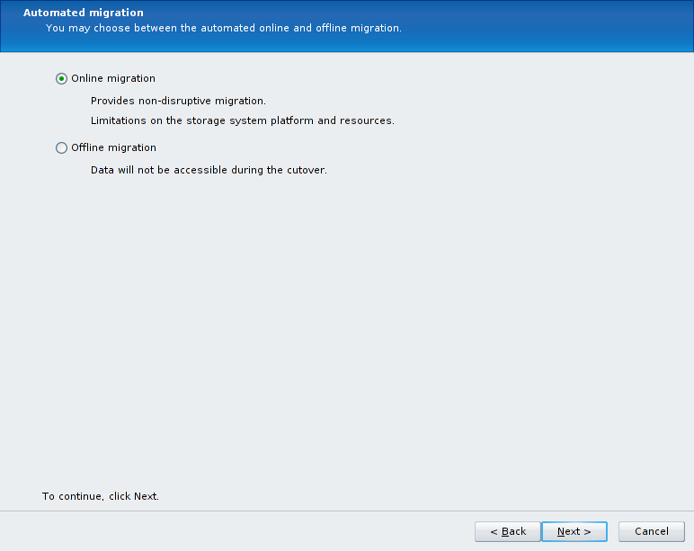

Note:

* Clients might experience the following during online migration:
  + ISCSI clients experience up to 120-second pause in input/output (I/O).
  + NFS clients experience up to 120-second pause in I/O.
  + Clients reestablish NFS locks as they would during a high-availability takeover.
  + CIFS client sessions are terminated after cutover, and the clients must reconnect

**(OR)**

2.2.a : Offline migration screen shot

Per the following screenshot. Assuming you want to move a vFiler and its data from one storage system to another disruptively you should select *Offline migration*

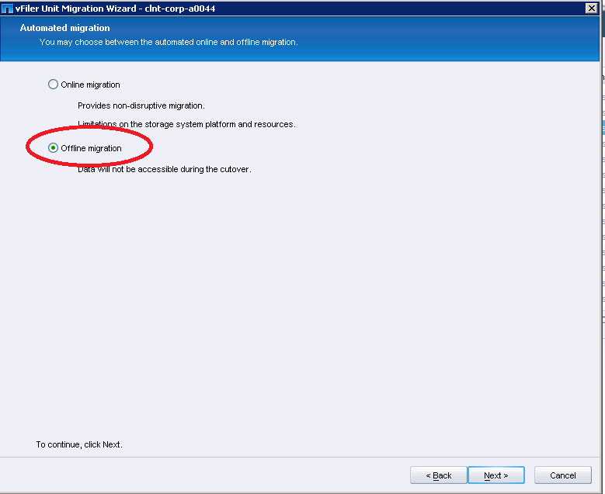

Note:

If it is offline migration application needs to be brought down before performing Final cutover

### 2.3 Choosing the destination storage system

In the next screen, choose the destination storage system. Reference the rules around Data Motion for vFilers as described in section 1.2 to determine the requirements for the destination system.

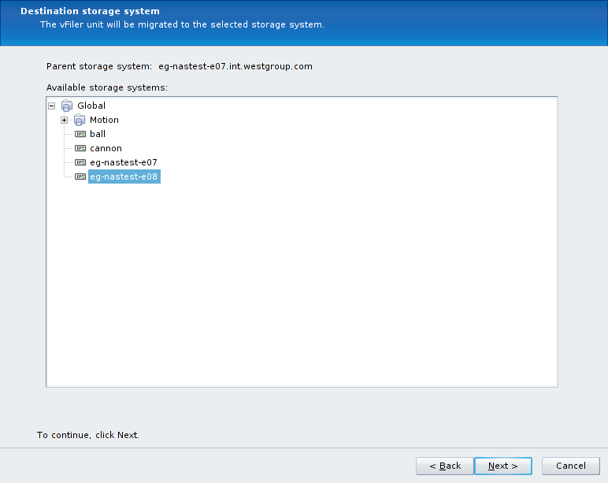

### 2.4 Modifying the aggregate mappings

If you wish to specify the exact destination storage system aggregate on which the flexvols for the vFiler will be placed, click on the *Customize the volume to aggregate mappings* checkbox as shown in the screenshot below. Then select each *Source volume*, select a *Destination aggregate* from the dropdown box, and hit the *Apply* button. This must be done for each source flexvol. If you choose not to customize the flexvol to aggregate mappings, Provisioning Manager will automatically select the destination aggregate with the most free space.

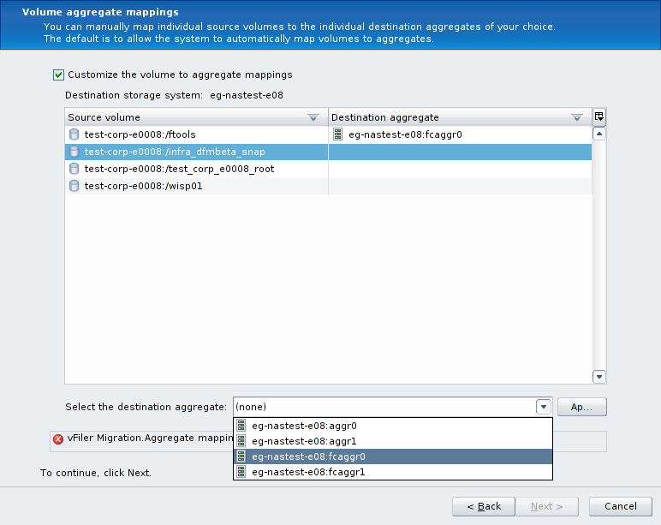

### 2.5 Configuring the network bindings

On the *Network interface settings* page, select the *IP address* of the vFiler and click on Edit:

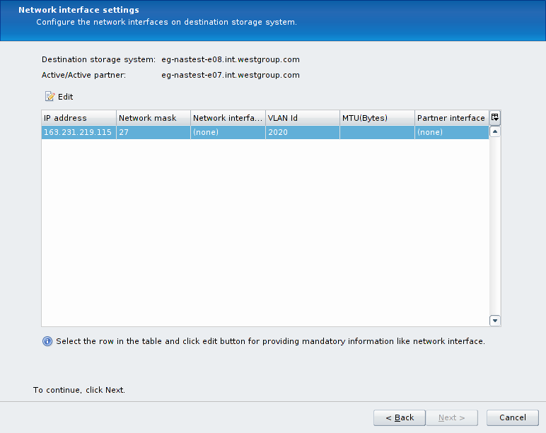

The first screen you will see when editing the network bindings will look something like the following screenshot. Note that the *Network interface* is set to *(none)* and the *VLAN Id* has a value.

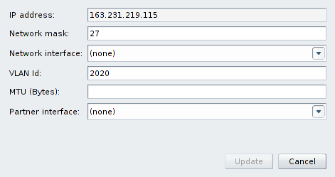

The items we need to modify in this form are the *Network interface* and the *VLAN Id*. The *VLAN Id* is pre-populated with the VLAN tag number, in preparation for creating a new VLAN tagged interface on the destination storage system. However, in the TRP environment, all of our VLAN tagged interfaces are pre-created, so we can simply remove this value as shown in the next screenshot. It is useful to use this VLAN tag number to find the corresponding interface to use in the *Network interface* list, as is also shown below:

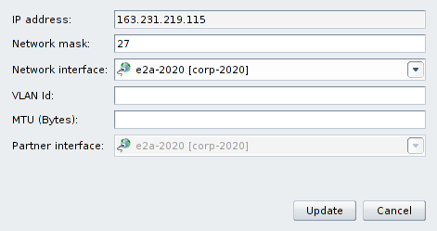

Note that it is not necessary to specify the *MTU* setting, nor is it necessary to modify the *Network mask* settings, and the *Partner interface* setting will be configured automatically. Once these changes are made, click on the *Update* button.

After clicking on the Update button, the *Network interface settings* screen will look similar to the following screenshot, and you can click on *Next* to continue.

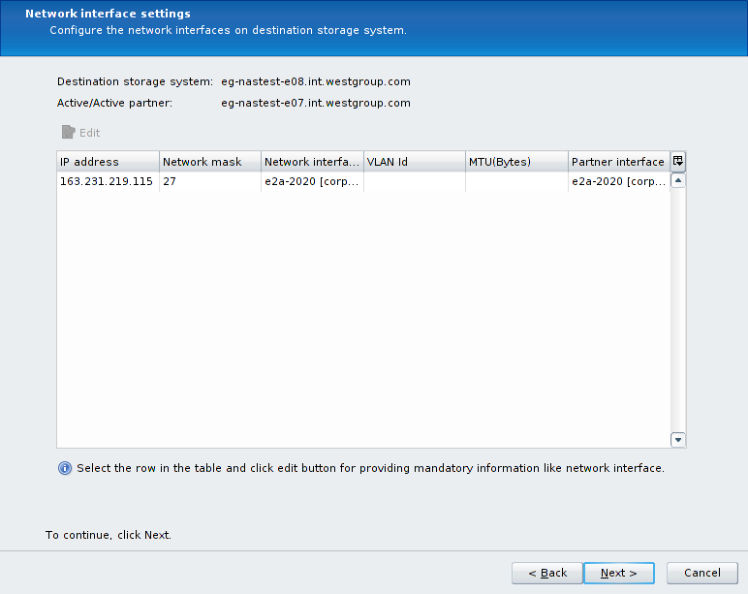

### 2.6 Specifying a transfer throttle

If you wish to specify a transfer throttle to limit the amount of network bandwidth used during the baseline SnapMirror data transfers, you may do so now. It should be noted that Data Motion for vFilers will use the TRP management interfaces (a non-vFiler IP address must be used) for SnapMirror traffic, which are 1GbE interfaces. Because of this, we will most likely not need to use a transfer throttle.

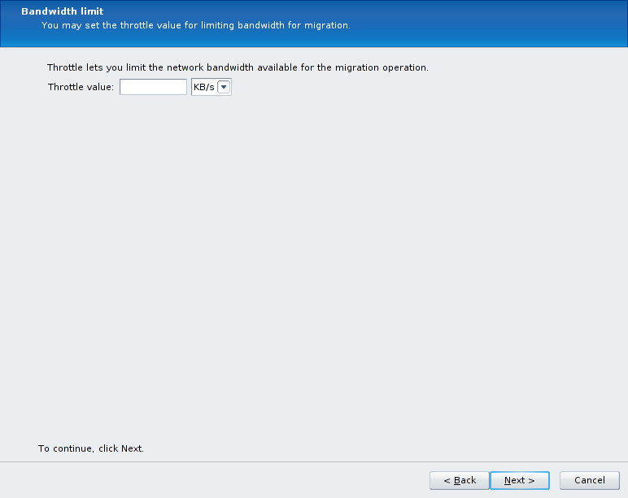

### 2.7 Choosing the cutover type

You can choose to have Provisioning Manager automatically perform the final cutover after the baseline data transfers are done, but we will typically like to perform the cutover during a controlled change window in the TRP environment. Therefore, this option will typically be left unchecked.

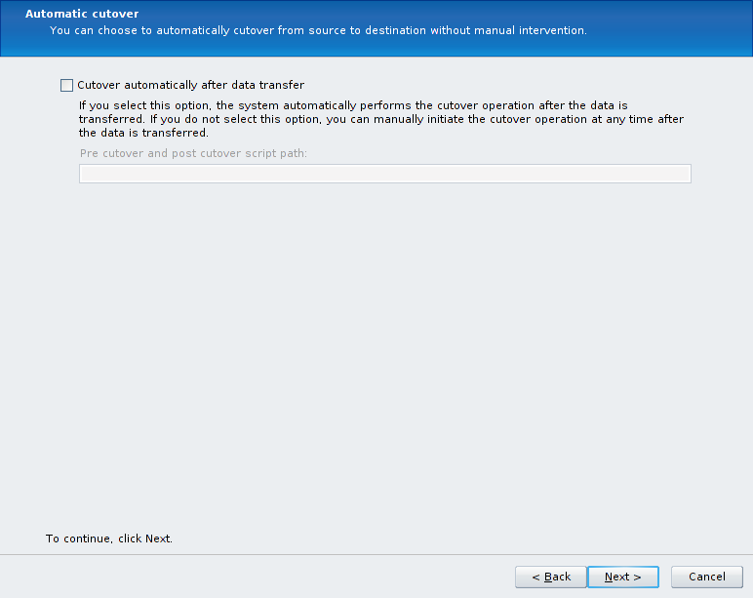

### 2.8 Final steps of migration initialization

The Preview screen will show you a summary of the steps that Provisioning Manager is about to perform. There should be no errors or warning on this summary screen.

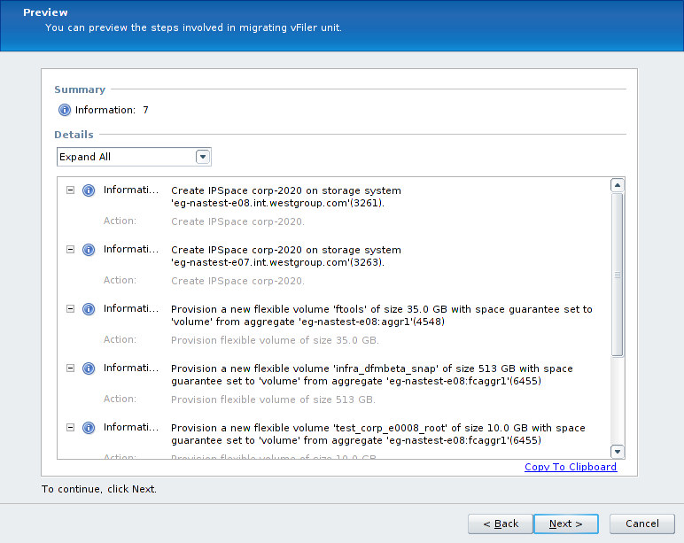

There is one final screen to hit *Finish* on in order to initiate the baseline data transfers:

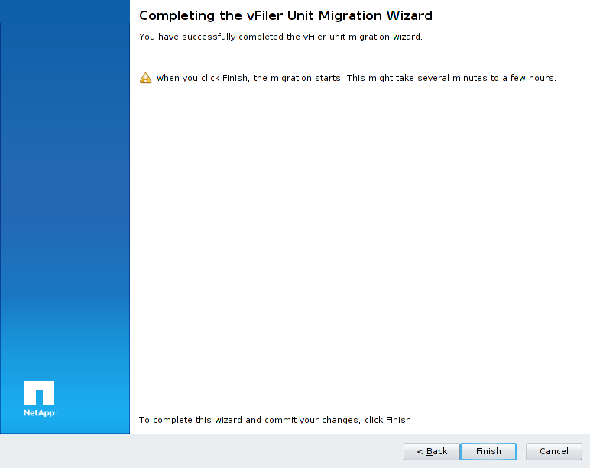

After hitting the *Finish* button, a task window is displayed that shows the progress as the flexvols are configured on the destination storage system:

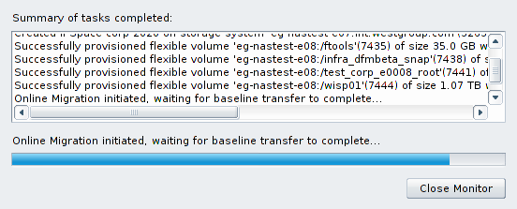

The main NMC interface will look similar to the following screenshot while the baseline data transfer is in progress:

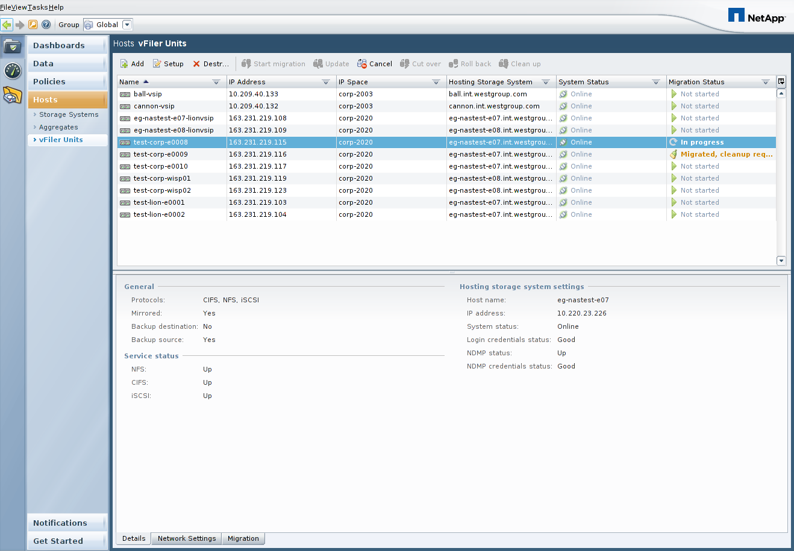

### 2.9 DFM alert when performing baseline data transfer

When the baseline data transfer is started, an offline vFiler is created on the destination storage system with the same name as the vFiler to be migrated. This will cause a DFM alert to be generated about this vFiler being offline, which can be safely ignored.

### 2.10 Updating the snapmirror.conf settings on the destination storage system

Snapmirror schedules in /etc/snapmirror.conf should be changed to run outside core working hours, typically 19:00 – 07:00 local. (See 2.5 for timing.)

The recommendation for the TRP environment is to change the SnapMirror update schedules in /etc/snapmirror.conf on the destination storage system as shown in the following example:

Original /etc/snapmirror.conf entry:

*srcfiler:srcvol dstfiler:dstvol – 0-59/3 - - -*

Recommended /etc/snapmirror.conf entry:

*srcfiler:srcvol dstfiler:dstvol –* * 19,1 * *

Stagger SnapMirror schedules, there should be no more than 10 starting at a single time.  
As an example change the SnapMirror schedules to these provided times using a round robin approach.

Set the first volume to * 19,1 * *  
Set the second volume to * 20,2 * *  
Set the third volume to * 20,2 * *  
Set the fourth volume to * 22,4 * *  
Set the Fifth volume to * 23,5 * *

This change should be made by manually editing the /etc/snapmirror.conf file with a unix based text editor such as VI, or using Wordpad (not Notepad) from a Windows client. The change will need to be made for all volumes involved in the DataMotion migration.

# 3 Performing the cutover

### 3.1 Checking the status of the data transfers and initializing the final cutover

While the baseline data transfer is in progress, you can check the status of the transfers by running the *netapp> snapmirror status* command on either the source or destination storage system. When the baseline data transfer is complete, the *snapmirror status* output will say *idle* for the flexvols involved in your Data Motion for vFilers migration, and the Provisioning Manager screen will report a *Migration Status* of *Started, cutover* *required* as shown in the following screenshot.

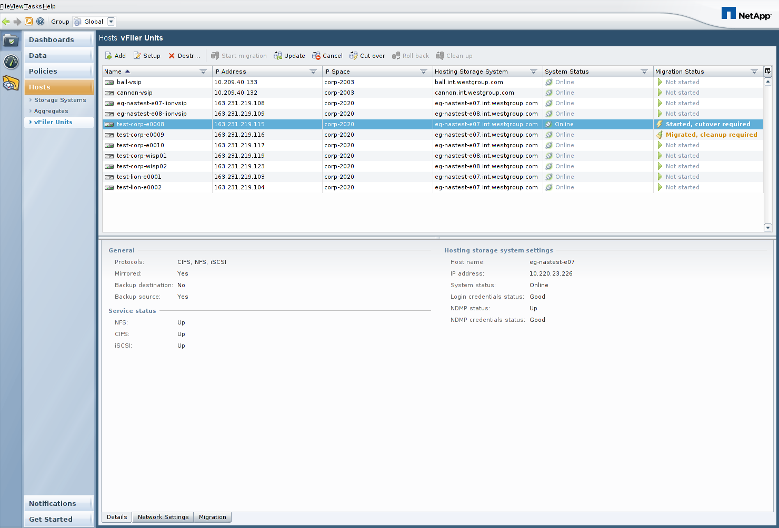

When you are ready to perform the final cutover, click on the *Cut over* button as shown above to initiate the final cutover process.

### 3.2 The script path option

The first screen in the *Cut over* wizard provides an option to run a script before and after the final cutover. This can be left blank in the TRP environment.

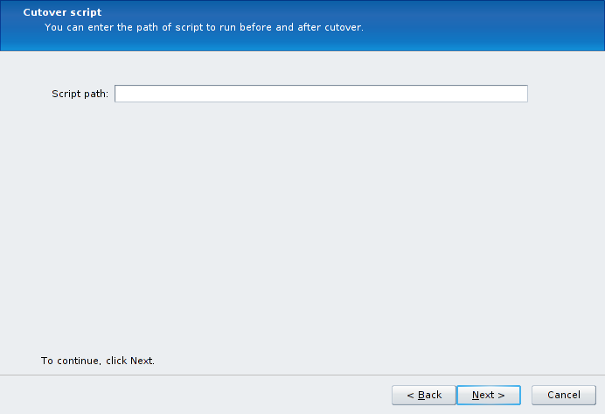

### 3.4 Network routes

The next screen allows you to specify which network routes will get migrated to the destination storage system. In the TRP environment, all of our default routes are held by the VSIP vFilers, so you should click on the *Do not migrate any routes* radio button.

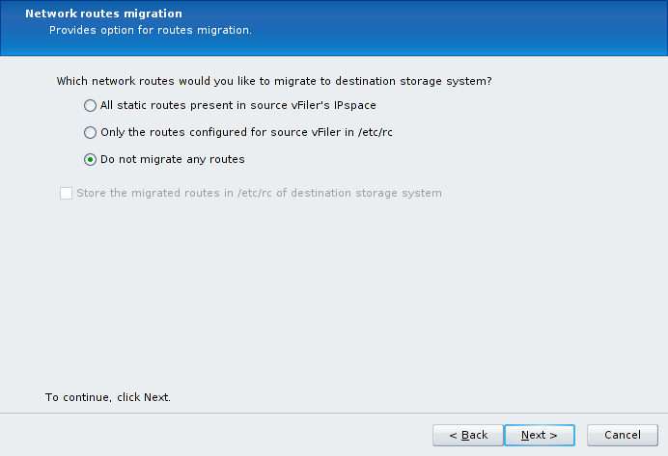

### 3.5 Cutover summary screen

In the Preview screen, you should expect to see a Warning that Provisioning Manager will be *Resizing the root volume* of the vFiler. This is to be expected, as 10GB is the minimum flexvol size for semi-synchronous SnapMirror relationships.

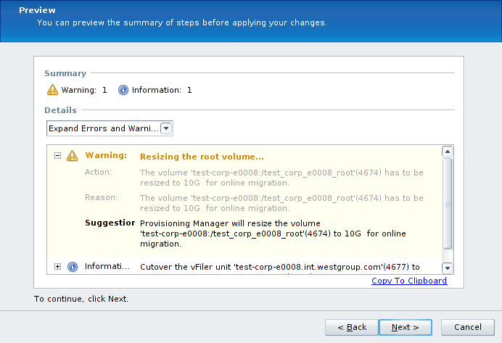

### 3.6 Finalizing the cutover

When you click on Finish in the following screenshot, the final migration cutover will begin.

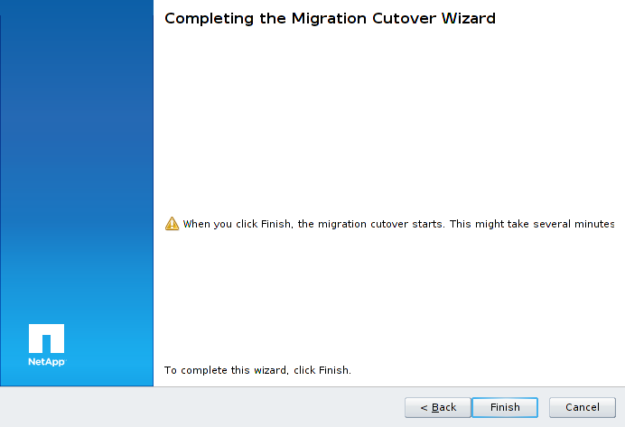

The screenshots on the following page will show what to expect during the final cutover process. Keep in mind that the final cutover process may take up to 30 minutes to complete as final synchronizations are configured, but the actual I/O pause during the final cutover for online migration will last less than 120 seconds.

First, the root flexvol is resized and the SnapMirror relationships are configured in semi-synchronous mode:

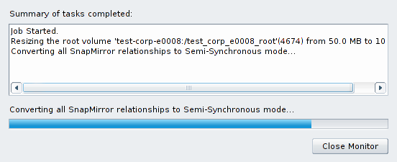

Once semi-synchronous mode is achieved, the vFiler is migrated:

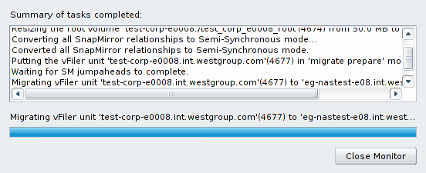

You will see a *vFiler unit <vfilername> successfully migrated* message when the migration is complete:

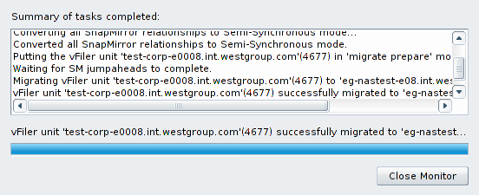

Back in the NMC interface, the *Migration Status* for this vFiler unit will show *Migrated, cleanup required*:

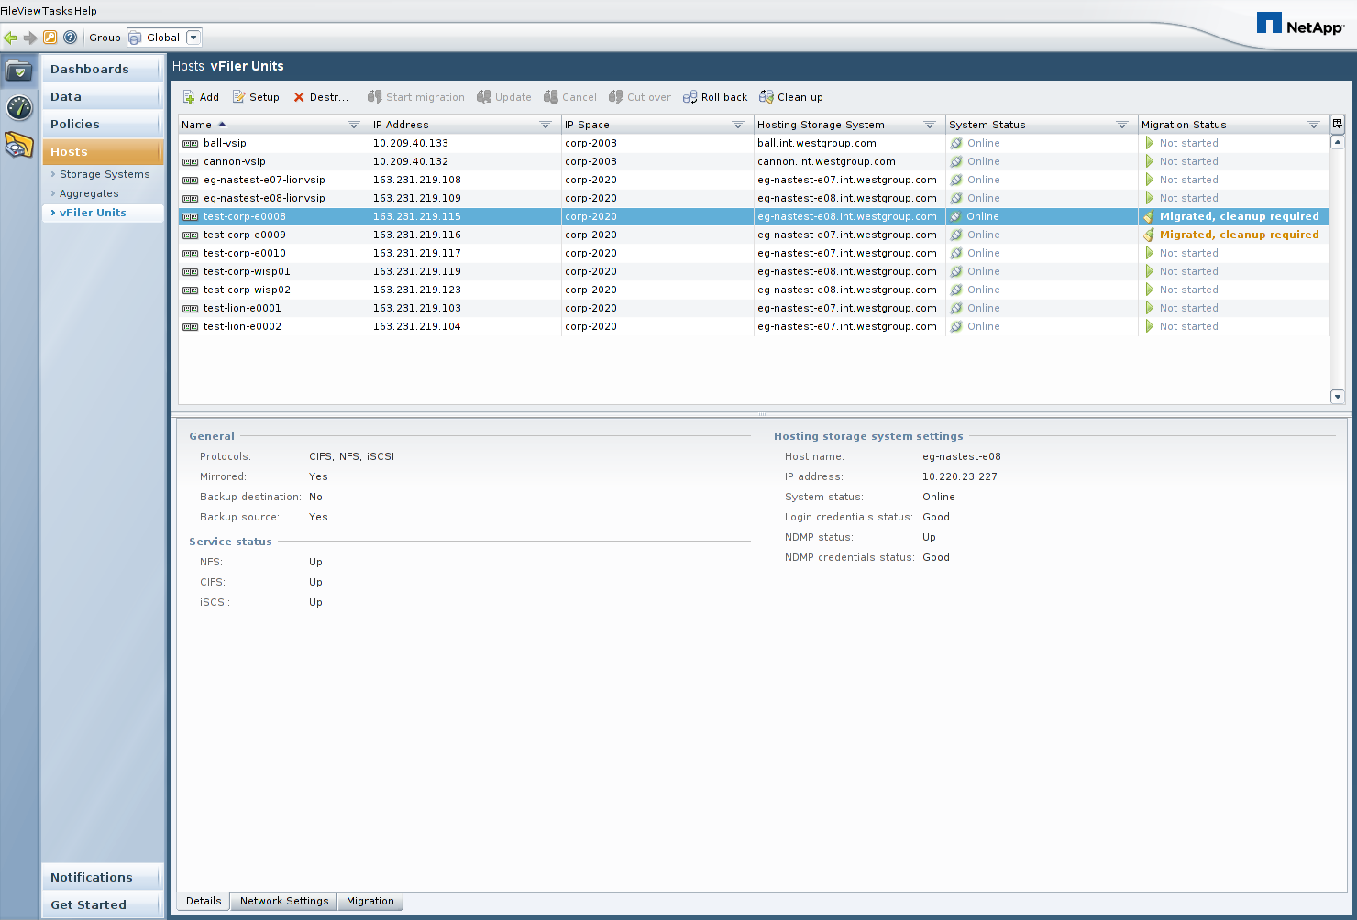

In the next section, we will discuss the required cleanup work.

### 3.7 Troubleshooting a failed cutover attempt

If the cutover attempt fails, the vFiler will continue running on the original source storage system. In order to determine why a cutover failed, it may be necessary to look at the contents of the *datamotion.log* file in the log directory of the DFM server. In the TRP environment, this is at */dfm/dfminst/log/datamotion.log* on all DFM servers. It is recommended to monitor the messages in this log file in real time during the cutover, in order to verify that things are proceeding as expected and to help quickly troubleshoot any problems. This can be done with the following command on the DFM server:

*dfm> tail –f /dfm/dfminst/log/datamotion.log*

4 Cleanup work

### 4.1 Cleaning up the source vFiler flexvols

If for some reason you need to put the vFiler back on the original source system shortly after the cutover, the Provisioning Manager interface has a *Roll back* button that can be used to do so without requiring a re-baseline data transfer. Use of this feature will launch a wizard interface similar to the *Cut over* wizard, and it will resync the SnapMirror relationships in the opposite direction prior to performing a cutover to put the vFiler back in place on the original source storage system.

If you are sure that no Roll back will be required, you can then use the Provisioning Manager interface to destroy the flexvols related to the migrated vFiler from the source storage system, using the *Clean up* button as shown in the screenshot below:



Once this Provisioning Manager *Clean up* task completes, there are two more steps required to complete the all necessary cleanup work for the TRP environment, as detailed in the next two sections.

### 4.2 Cleaning up SnapMirror related snapshots

The Provisioning Manager interface does not remove the flexvol snapshots created by the SnapMirror process. SnapMirror flexvol snapshots will exist on the flexvols owned by the migrated vFiler on the destination storage system, and they will be in the following format:

*dest_filer(sysid)_name.number*

* *dest_filer* is the host name of the destination filer.
* *sysid* is the destination system ID number.
* *name* is the name of the destination flexvol.
* *number* is the number of successful transfers for the Snapshot copy, starting at 1. Data ONTAP increments this number for each transfer.

You can use the Data ONTAP CLI, FilerView, or Provisioning Manager to remove the snapshots in this format from all flexvols owned by the migrated vFiler.

### 4.3 Correcting the dataset physical properties

After a vFiler is migrated from one physical storage system to another, the Provisioning Manager datasets related to the vFiler must be updated to reflect the new resource pool in use. This is required because resource pools are logical constructs that could span many storage systems, and as such Provisioning Manager has no way of knowing that in the TRP environment we define one resource pool per physical storage system. To correct the resource pool configuration, go to the following section of the Provisioning Manager interface for each dataset (flexvol) owned by the migrated vFiler:

*NMC->Provisioning Manager->Data->Datasets-><select dataset>->Edit->Provisioning/Resource Pools->Resource Pools*

This section of Provisioning Manager will allow you to remove the old physical storage system resource pool and add the new physical storage system resource pool for the dataset.

# 5 Resources

Provisioning Manager Administration Guide:

<https://now.netapp.com/NOW/knowledge/docs/DFM_win/rel40/html/software/workflow/frameset.html>

Data Motion Technical Report

<http://media.netapp.com/documents/tr-3814.pdf>